1. A teaching evaluation was conducted for a particular course. Students’ responses were collected using the following scale: 1 = Strongly Agree, 2Agree, 3 = Neutral, 4= Disagree, 5 = Strongly Disagree. The responses indicate what level of measurement?

<https://www.statisticshowto.com/probability-and-statistics/statistics-definitions/nominal-ordinal-interval-ratio/>

1. Interval
2. Ratio
3. Nominal
4. Ordinal
5. A team of psychologists interested in sleep deprivation’s effects on post-covid-19. Covid-19 patients (N=10) stay in sleep lab for 2 days. Five participants are randomly assigned to an experimental condition; the other five participants can sleep when they wish. At the end of two days, all patients attended a training session. After the session, a test was conducted. Which of the following statistics would you recommend to test their hypothesis?

<https://www.wyzant.com/resources/answers/849938/help-exp-psych-im-so-confused-with-what-should-i-use> 1.2

1. Independent Samples T-Test
2. Linear Regression Analysis
3. Chi-square Test of independence
4. Dependent Samples T-Test
5. Three bands of tea are rated for taste on a scale of 1 to 10. Six persons rate each brand so that there is a total of 18 observations. Which of the following test is appropriate to determine if the three brand tastes are equal?
6. Kruskal Wallis
7. Chi-square test of independence
8. Mann Whitney
9. Wilcoxon
10. Which t-test would be used for the following situation? Comparing employee statiscation at Company A and Company B.
11. One sameple t-test
12. Dependent t-test
13. Variance t-test
14. Independent t-test
15. An independent t-test analysis compares a randomly assigned group of 16 participants who received a psychotherapy intervention on their changes in thought suppression to a control group (n=16) who received the treatment later. Thought suppression is measured and high scores represent higher perceived thought suppression. How should the hypothesis be written for the given test?

<https://quizizz.com/admin/presentation/604902ff3bf760001c3586f7/t-test-dependent-and-independent> Q19

1. Ha : µpsychotherapy = µcontrol
2. Ho : µpsychotherapy > µcontrol
3. Ha : µpsychotherapy ≠ µcontrol
4. Ho : µpsychotherapy = µcontrol
5. Which does NOT describe a Dependent t-test?
6. It compares the median of the same group.
7. It compares data from different time.
8. It compares the mean of the same group.
9. It is also known as Paired Sample Test.
10. The T-TEST is used when n<30 and only the sample standard deviation is given as a basis for estimating the population standard deviation.
11. True
12. False
13. Which one of the following variables is not categorical?

<https://www.coursehero.com/file/16126724/Quiz-2/>

1. Gender of a person
2. The choice on the test item
3. Marital status of a person
4. Age of the person
5. When testing with α = 0.01, you get p = 0.12. interpret the results
6. Accept Ho and there is a significant difference
7. Reject Ho and there is NOT a significant difference
8. Accept Ho and there is NOT a significant difference
9. Reject Ho and there is a significant difference
10. For a random sample of 9 women, the average resting pulse rate is x = 76 beats per minute, and the sample standard deviation is s = 5. The standard error of the sample mean is:

5/√9

1. 1.667
2. 0.557
3. 2.778
4. 0.745
5. A hypothesis test is done in which the alternative hypothesis is that more than 10% of a population is left-handed. The p-value for the test is calculated to be 0.25. which statement is correct?

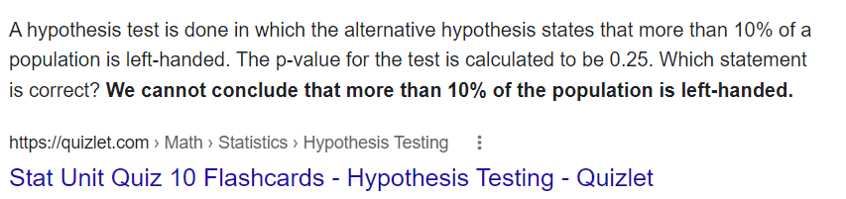

1. We cannot conclude that more than 10% of the population is left-handed.
2. We can conclude that more than 10% of the the population is left-handed.
3. We can conclude that precisely 25% of the the population is left-handed.
4. We can conclude that more than 25% of the the population is left-handed.
5. A person has 8 red, 5 green, 12 organge, and 15 blue balls. Test the null hypothesis that the colours of the balls occur ith equal frequency. What is the Chi-Square value?

EF = (8+5+12+15)/4 = 10

X² = (OF-EF) ²/EF

X² = (8-10)²/10+ (5-10) ²/10+(12-10) ²/10+(15-10) ²/10 = 0.4 + 2.5 + 0.4 + 2.5

1. 5.86
2. 5.68
3. 5.8
4. 5.6
5. In hypothesis testing, a type 2 error occurs when

<https://www.investopedia.com/terms/t/type-ii-error.asp#:~:text=A%20type%20II%20error%20does,for%20rejecting%20a%20null%20hypothesis>.

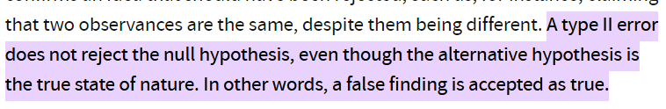

1. The null hypothesis is not rejected when the null hypothesis is true
2. The null hypothesis is rejected when the null hypothesis is true
3. The null hypothesis is rejected when the alternative hypothesis is true
4. The null hypothesis is not rejected when the alternative hypothesis is true
5. A chi-square test whether a 0 to 9 spinner is “tail” (that is, the outcomes are all equally likely). The spinner is spun 100 times. The degrees of freedom for the test will be:

n= count {0,….,9} = 10, n-1 =9

1. 9
2. 8
3. 10
4. 99
5. Which Test is Appropriate? A stadium manager is interested in whether the fans who buy tickets are demographically the same as the city’s general population. Currently, 42% are Caucasian, 35% are Hispanic, 12% are African American, 8% are Asian, and the test are defined as other
6. Not a Chi-Square test
7. Chi-Square Goodness of Fit Test (**used to determine whether a variable is likely to come from a specified distribution or not**)
8. Chi-Square Test for Homogeneity (**tests to see whether different columns (or rows) of data in a table come from the same population or not**)
9. Chi-Square Test for independence (**used to determine whether two categorical or nominal variables are likely to be related or not**.)
10. What is data visualization?
11. It is the numerical representation of information and data
12. It is the character representation of information and data
13. None of the given opitions
14. It is the graphical representation of information and data
15. Tableau Desktop – A easy to use business analysis and data visualization software that shows pictures of data into optimized queries, allowing you to perform queries withour writing code.
16. True
17. False
18. Data visualization tools provide an accessible way to see and understand _____ in data.
19. Trends
20. All of the given options
21. Patterns
22. Outliers
23. Which method shows hierarchical data in a nested format?
24. Scatter plots
25. Treemaps
26. Area charts
27. Population pyramids
28. What are the common issues you encounter when working with large amonts of data?
29. Veracity can be an issue, as it’s sometimes hard to determine if all values are true.
30. Because of the fast belocity of its generation, assessing its quality can be very difficult.
31. Volume may overwhelm and make a complete analysis difficult.
32. All of the option given
33. Wide variety of data is sometimes challenging to structure.
34. The improtance of data visualization are:
35. Leading the target audience to focus on business insights to discover areas that require attention.
36. Revealing previously unnoticed key points about the data sources to help decision makers compose data analysis reports.
37. Helping decision makers understand how the business data is being interpreted to determine business decisions.
38. All of the option given
39. The charts that are helpful in making comparison between
40. Column charts
41. Both Bar and Column charts
42. Pie charts
43. Bar charts
44. A __ is a line that provides an approximation of the relationship between the variables.
45. Gridline
46. Sparkline
47. None of the option give
48. Trendline
49. Which module of matplotlib library is required for ploting of graph
50. None of the option give
51. Plot
52. Pyplot
53. Matplot
54. Which of the following information you COULDNET gain from box-plot?
55. Lower/uper quartile
56. None of the options given
57. Median
58. Dispersion
59. Outliers
60. Min/Max score
61. What features might be visible in scatterplots?
62. Clusters: sometimes there could be groups of data that form a cluster on the plot.
63. Correlation: the two variables might have a relationships, for example, one might depend on another.
64. All the options given
65. Outliers: there could be cases where the data in two dimension does not follow the general pattern.
66. What type of plot would you use is you need to demostrate “relationship” between variables/parameters?
67. Scatter plot
68. Heatmap
69. None of the option give
70. Bar chart
71. What plot would you use to plot the distribution of the variable?
72. Heatmap
73. None of the options given
74. Histogram
75. Scatter plot
76. Which graph makes it easier to determine which investment has greater market share?

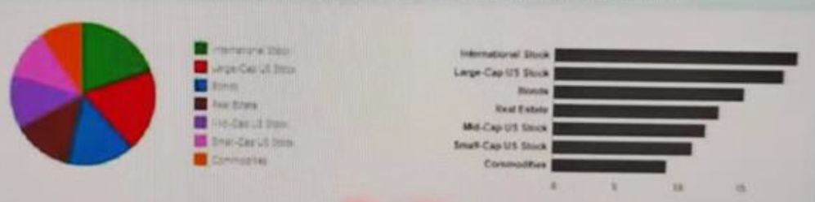 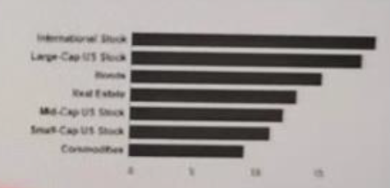

Option A Option B

1. Option A
2. Option B
3. Which graph accurately encode the values and doesn’t skew the value that results in misleading interpretation?

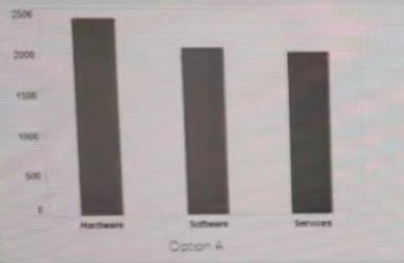 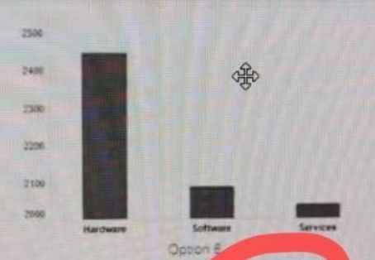

1. Option B
2. Option A